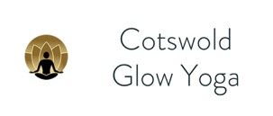

New Yoga Student – Contact Form

Name _________________________

Email* _________________________

Date of Birth _________________________

Phone _________________________

I understand that I must inform the teacher before the start of the class of any current injuries or medical conditions, whether or not I feel it is relevant to my taking part in the class. Cotswold Glow Yoga will take all reasonable care in teaching me in class based on the information I provide. I acknowledge that any practical activity can involve some risk of injury. I assume any such risk and accept responsibility for any injury sustained, and discharge and hold Cotswold Glow Yoga and its teachers, from any liability arising from any injury to myself

Signed ___________________________

Date ___________________________

*I am asking for your email so that I can let you know of any class cancellations or changes and to keep you up to date on new classes and events, I don’t share your information with anyone else, but no need to give it if you’d rather not receive this information